Tutorial 2 Answer

1. Theory

Answers

Ex 1.

1.i 2d. 3.b. 4j. 5h. 6l. 7e. 8c 9g. 10a. 11.f. 12.k

Ex 2. Contrast the following terms:

1. *Stored attribute; derived attribute*  A stored attribute is one whose values are stored in the database, while a derived attribute is one whose values can be calculated or derived from related stored attributes.
2. *Simple attribute; composite attribute*  A simple attribute is one that cannot be broken down into smaller components, while a composite attribute can be broken down into component parts.
3. *Entity type; relationship type*  An entity type is a collection of entities that share common properties or characteristics, while a relationship type is a meaningful association between (or among) entity types.
4. *Strong entity type; weak entity type*  A strong entity type is an entity that exists independently of other entity types, while a weak entity type depends on some other entity type.
5. *Degree; cardinality* The degree (of a relationship) is the number of entity types that participate in that relationship, while cardinality is a constraint on the number of instances of one entity that can (or must) be associated with each instance of another entity.
6. *Required attribute; optional attribute*  A required attribute must have a value for each entity instance, whereas an optional attribute may not have a value for every entity instance.
7. *Composite attribute; multivalued attribute* A composite attribute has component parts that give meaning, whereas a multivalued attribute may take on or more values for an entity instance.

*Ex 3*

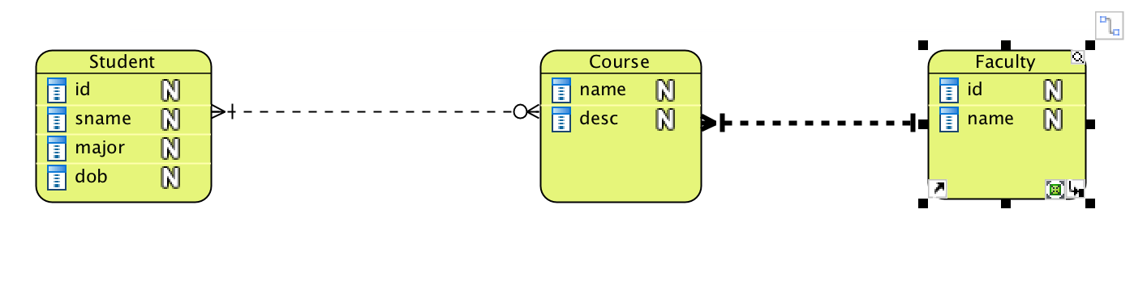

*Ex 4*

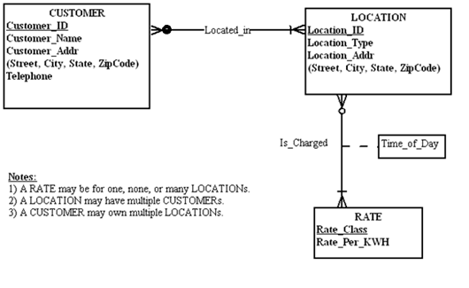

Ex 5.

